An Interview with
Karen Haberberg about her book,
An Ordinary Day – Kids with Rare Genetic Conditions
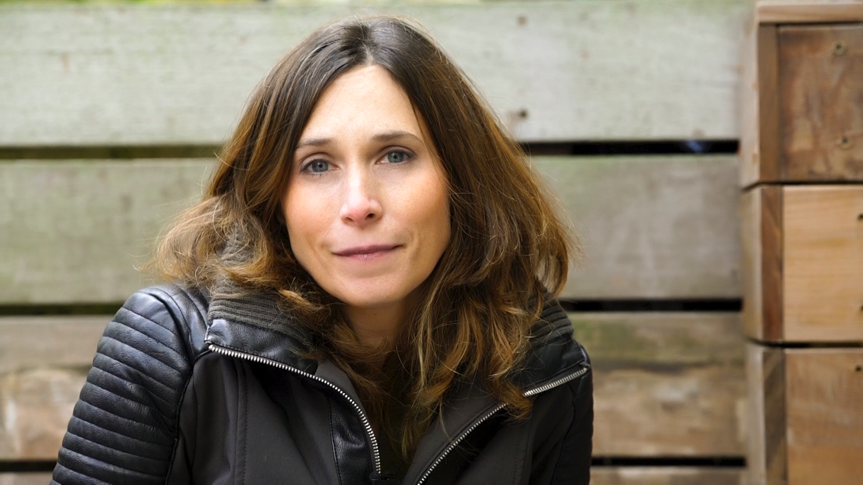

Q: How did you decide to photograph families raising children with rare genetic conditions?
A: “An Ordinary Day” was a labor of love for me. My parents lost a child to Tay Sachs Disease before I was born and almost 50 years later, they still suffer from the loss of my brother, Rafi.

More recently, my best friend’s son was diagnosed with Angelman Syndrome. Hearing her struggles and victories made me realize how little attention families who have children with rare genetic conditions receive and how common it actually is. One in 10 families in America has a child with a rare condition and 95% of those conditions do not have one single FDA approved drug treatment

Q: In your book, you captured some incredibly intimate moments between parents and their kids. How did you gain their trust to tell their personal stories through photography?
A: All the families in the book are extraordinary. I am incredibly fortunate to have been allowed into their intimate world. I am in awe of their strength, optimism and perseverance.

I was there to tell their story as authentically as possible, and I think they felt that, which is what enabled them to open up to me. I deeply care about each family represented in the book, and find found them to be incredibly inspirational.

Q: You ran a successful Kickstarter campaign that raised more than $25,000 to get “An Ordinary Day” off the ground. Why do you think there was such overwhelming support for this project?
A: One of the goals of this project was designed to get the word out on a population that is often overlooked and sometimes even shunned from society. People recognized the need for the book as an effort to raise awareness on a variety of genetic conditions, to help fund research for treatments, and to connect families with kids who have rare genetic conditions to each other and the world at large. In addition, the profits of the book go to genetic research and the Kickstarter video explains my goals clearly.

Q: What was the best and most difficult parts of working with the kids and families featured in your book?
A: It’s been an honor and privilege to work with each of the families, but given the topic, there were some difficult moments emotionally during the interviewing process. While we may have shed a few tears together, their honesty and my empathy was a beautiful thing. I only want the best for these kids, and I think the parents recognized that.

Q: Have your own kids shown interest in photography? What did they think about the project?
A: My kids are at the age that they most appreciate photographs of fuzzy animals or landscapes. The most important thing I want my kids to come away with from this project is how important it is to accept all kinds of people. They know that no one is perfect and we are all working on things. It’s critical that they don’t judge, shy away from, or exclude kids who are different. I think they got that message now.

Q: What is something you would like to communicate to people who have not spent a lot of time around kids with special health needs?
A: Many of the parents in the book comment that most of the people they socialize with since their child was diagnosed are from the rare genetic disease community. Their friends with typical kids no longer invite them to parties because they worry that if the kids with a rare condition attends the birthday party and the kid has an outburst or a behavioral issue, the party will be ruined. It’s a shame because the families who have kids with rare genetic conditions already feel isolated. They are already struggling with medical care, insurance companies, schools and everyday life. People who haven’t been closely exposed to families like these are often ignorant and fearful, which is what causes them to step away rather than lean in. It’s time we lean in. We need to teach tolerance to all ages.

Q: Outside of this project, you are also an award-winning portrait and commercial photographer. Did you approach your work for “An Ordinary Day” with a different mindset?
A: In all of my work, I assess the situation at hand and figure out the best way to present the person or project. “An Ordinary Day” was challenging on a lot of levels, but from an aesthetic sense, I couldn’t plan too much because I wasn’t very familiar with the situation I was entering. Fortunately, it always ended up authentic, beautiful, and individual.

Q: Deep emotion radiates through the images you captured. Were you ever emotionally overwhelmed during the project? How did you handle that?
A: There were definitely more than a handful of moments when parents were talking to me candidly that I choked back some tears. Watching these kids and families repeatedly work as hard as they do to learn basic skills and move forward, which could be as simple as eating, was heartbreaking at times. These families persevere because they have to, but they do it with such profound grace that it’s astonishing; I deeply respect them.

A handful of the families have started their own organizations to raise money and awareness for their child’s condition and have really helped propel forward research in their specific areas.

Q: What surprised you about the project?
A: What I did not expect was how connected I would feel to the families. Now, I am constantly following them on Facebook and I now have 27 more people to worry about!

Q: Rare Disease Day will be observed on Feb. 28, 2020, to help spread worldwide awareness of uncommon health conditions. What are some ways people can show their support and make a difference in their own communities?
A: Global Genes does an amazing job at advertising different ways to spread the word about rare genetic conditions and support the cause.

Q: What’s next for you?
A: While I continue to expand my commercial work, I will be working on a multimedia project on Transgender Youths.

In addition, I am starting a company with an Emmy Award-winning team to create high-end video documentaries for individuals and families to tell their story and keep their memory alive. They will be individually made, authentic, and professionally produced. It's an exclusive and limited opportunity – only a few will be made each year. It's the perfect gift for someone you admire and respect – to tell their story, their way and to preserve their legacy for generations. This will be something very unique to what you have seen out there in this arena. Stay tuned!

Q: Last thoughts!
A: When I returned home after each shoot I always gave my kids an extra strong hug and reminded myself – don’t sweat the small stuff. Be grateful, and I am.

